# Synopsis

This web system is designed to meet Ger’s mechanical garage needs. It is a small garage which carries out any type of services and repairs on cars, motorbikes, small vans and small buses.

Ger manages a small team of 5 mechanics. All those employees are able to maintain different types of vehicle and perform any service or repair. In some cases, maintenance check will require parts or supplies (e.g. fluids, oil, tyres) which the staff will look for in the stock of supplies from the garage and invoice the customer for.

This web system will allow Ger’s customers to book different types of service or repairs for their vehicle, on the day they want. It also gives Ger access to the bookings in order to manage staffing and work flow.

# Computing General Areas

I’ve chosen to use Java 8, MySQL, JPA, Spring, Angular, Tomcat and Gradle to cover all the garage web system areas:

* Java: object oriented language widely spread and therefore many professionals, forums and guides are available for help and guidance.
* MySQL: It’s a robust database which can process a huge amount of data and at the same time this DB is open source.
* JPA: this API which maps the database using annotations, and this makes easier to manage queries on the DB.
* Spring: This framework is used to build micro services which can be accessed by other systems even if they don’t support Java because as Spring uses JSON mostly.
* Tomcat: It provides a HTTP web server environment which Java code can run.
* Gradle: This is an open-source build automation system based on Apache Ant and Apache Maven.
* Angular: It’s a TypeScript-based open-source web application framework.

# Proposed Plan

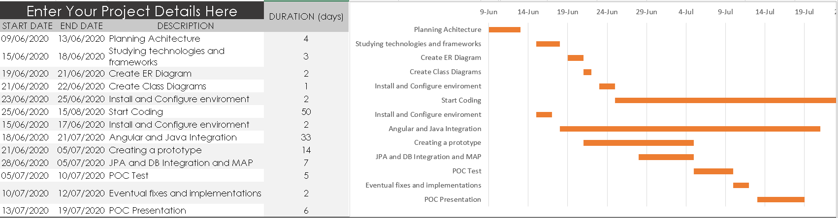

# Project Reason

The garage application will be used for Ger, his customer and staff. With it Ger will be able to admin garage stock, staff, customers sign up, bookings and services. Also, the system is to allow staff and customer to check their booking and details out. Customers can log in on the system, make their appointments by date and time availability and describe the service details. While the staff can verify which booking and services they are responsible for.

The application also allows Ger print the schedule for any particular date, allocate costs to each booking or a basic fixed cost.

All of those will be managed through the Garage System giving Ger more time and better experience of controlling his business.

This project aim to be simple. Working with open source technologies Ger have no needs for paying products licences. In additional, stacks as Java, Spring, JPA and others included on this application are commonly used in the current days. By consequence, the number of developers with knowledge to support or implement is very high.

# Use Case

The application has been being built to serve small garages but can also attend to others businesses which the work flow is offering service (e.g hairdresser, computer maintenance, health consulting and others). In additional, as it is web service based, new modules can be build and bigger garage business will be able as well.

The system is made on modules which each of them are built separately. It allows the application an exponential growth and makes easier to include new attributes or functionalities. Also, troubleshooting and fixes become simpler because it’s possible isolate the problem. New modules can be added too (e.g. payments and e-invoice).